BVS.2.11 Pre-Assessment
(*Do not answer on this page. Please use GradeCam answer sheet from front desk)

Word Bank

- absurd
- adhere
- affluent
- alienate
- assess
- compile
- contempt
- defect
- doctrine
- dogmatic

Matching vocabulary terms to possible antonyms and definitions – Please match the words from above to one of these antonyms or definitions.

- a fault
- a teaching
- disrespect
- one-sided
- rich
- ridiculous
- to judge
- to push away
- to put together
- to stick

BVS.2.11 Pre-Assessment
(*Do not answer on this page. Please use GradeCam answer sheet from front desk)

Word Bank

- absurd
- adhere
- affluent
- alienate
- assess
- compile
- contempt
- defect
- doctrine
- dogmatic

Matching vocabulary terms to possible antonyms and definitions – Please match the words from above to one of these antonyms or definitions.

- a fault
- a teaching
- disrespect
- one-sided
- rich
- ridiculous
- to judge
- to push away
- to put together
- to stick

Name:__________________
Date:___________________
Period:__________________
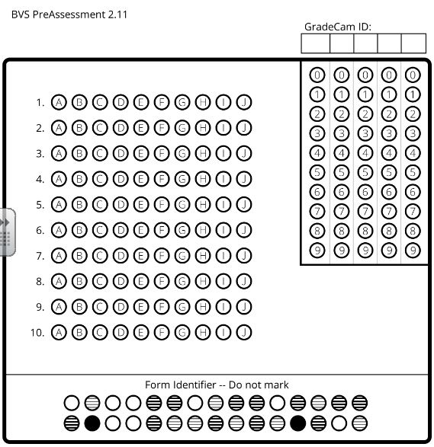

Name:__________________
Date:___________________
Period:__________________

